**Gracious Germents**

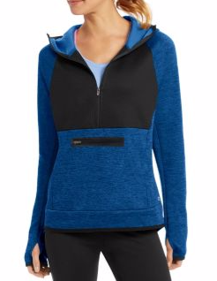

**DESCRIPTION:**

Premium Tech Fleece Half Zip is the perfect go-to layer for warm-ups or cool-downs.

Lightweight with Duofold Warm CTRL™, that comfortably locks in warmth.

Brushed interior helps hold the body’s heat without adding weight.

Wicks moisture away from skin for optimum comfort.

Heather body with honeycomb textured front and back piecing.

Stow essentials in low profile onseam pockets.

Full coverage scuba hood.

Droptail and thumbholes protect against elements.

Stretch trim at cuffs and bottom hem.

Reflective details and C logo at hem.

**ADDITIONAL INFORMATION**

Weight: 0.5 kg

Dimensions: 10 × 8 × 3 cm

Size: S, M, L, XL,

Price: $20.00